**Data Governance and Refinery – Workshop**  
**1. Pre-requisite**   
Create an IBM Cloud account – [IBM Cloud](https://cloud.ibm.com/registration) .   
Once you have a verified IBM Cloud account (via email) , [Sign In to IBM Cloud](https://idaas.iam.ibm.com/idaas/mtfim/sps/authsvc?PolicyId=urn:ibm:security:authentication:asf:basicldapuser).  
Clone the repo **–** [**https://github.com/sauravraiguru/Data-governance**](https://github.com/sauravraiguru/Data-governance)

If you do not have the IBM cloud services listed below, click the links to create the free 'Lite' version of them:

* [Watson Studio](https://console.bluemix.net/catalog/services/watson-studio)
* [Watson Knowledge Catalog](https://console.bluemix.net/catalog/services/knowledge-catalog)
* [Cloud Object Storage](https://console.bluemix.net/catalog/services/cloud-object-storage)

Go to the IBM Cloud [Resource List](https://cloud.ibm.com/resources) that you have just now created and search for your ‘Watson Studio’ service.

**2. Log in to IBM Watson**

In this task, go to the IBM Watson Studio URL and Login to your IBM Watson account, so you can complete the remaining tasks.   
This is your IBM Watson account that you were instructed to create in the **Prerequisites** section of this tutorial.

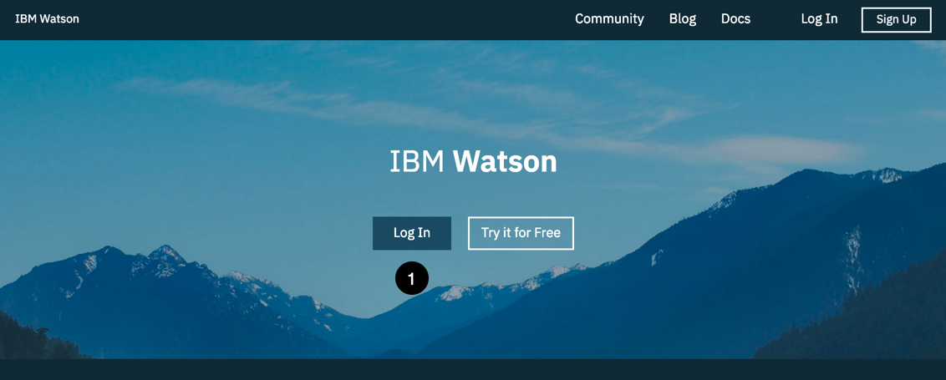

Go to [IBM Watson](https://dataplatform.ibm.com/) and login to your IBM Watson account.

1. Click the **Log In** button in the middle of the page.

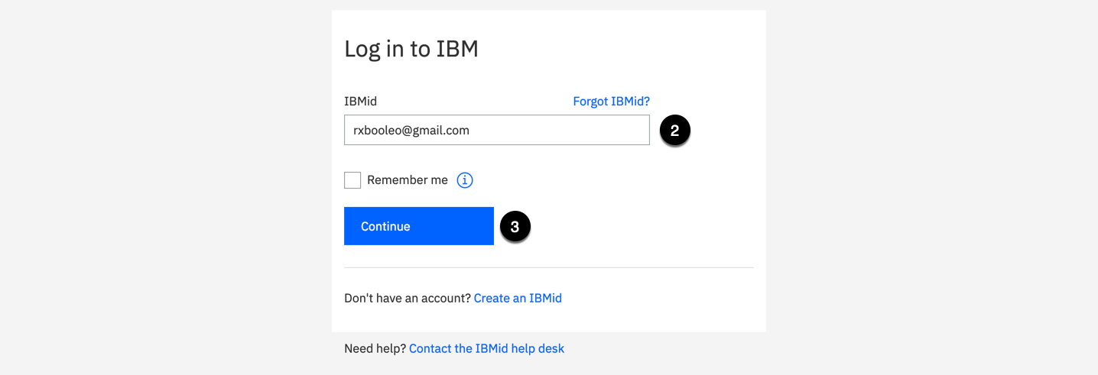

2. Enter your **IBMid**.

3. Click the **Continue** button.

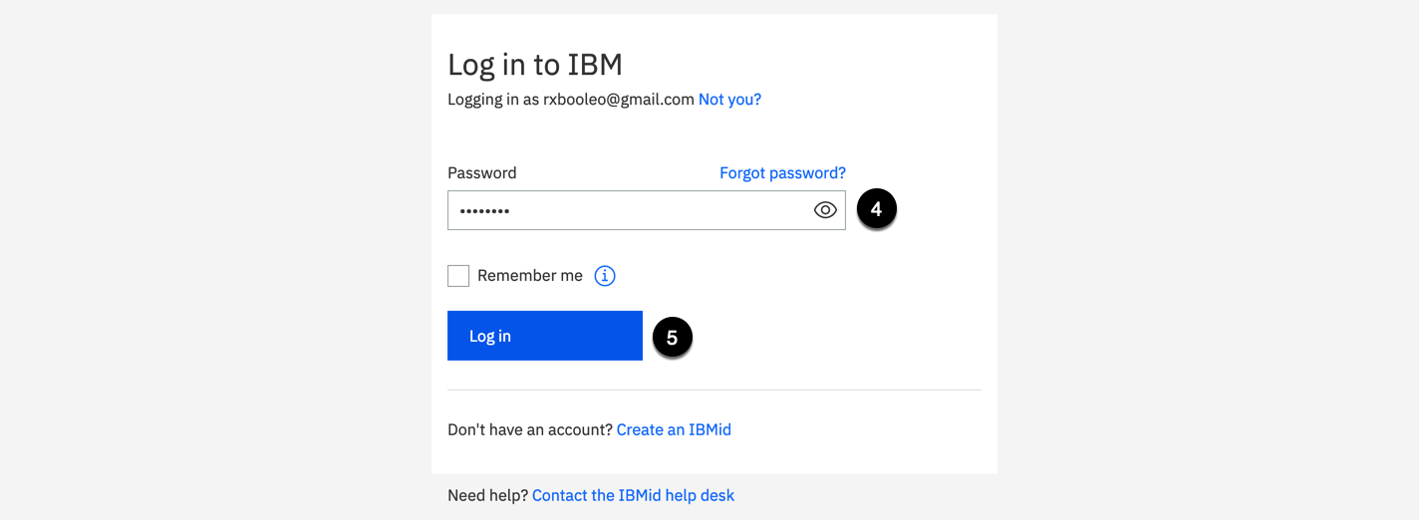

4. Enter your **Password**.

5. Click the **Log in** button.

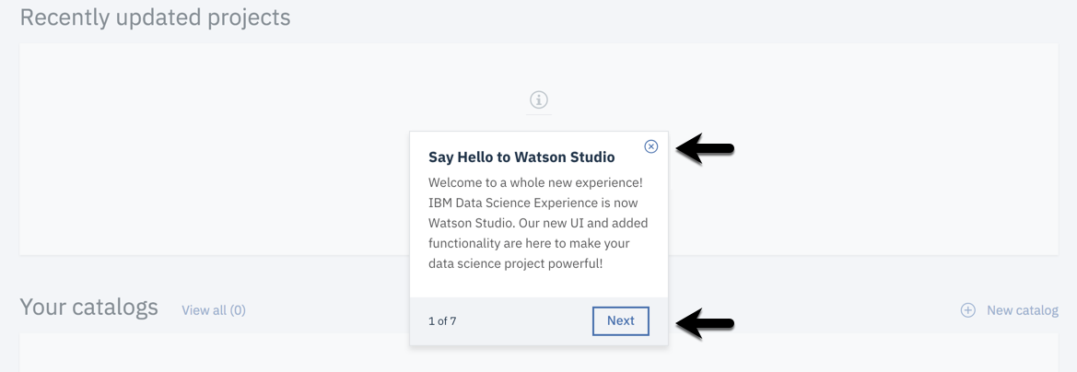

If you see a **Say Hello to Watson Studio** or **Welcome to Watson Studio** dialog box, click the **X** in the top right corner to close the dialog or select the **Next** button to take the introduction tour. The dialog will close when the tour is complete.

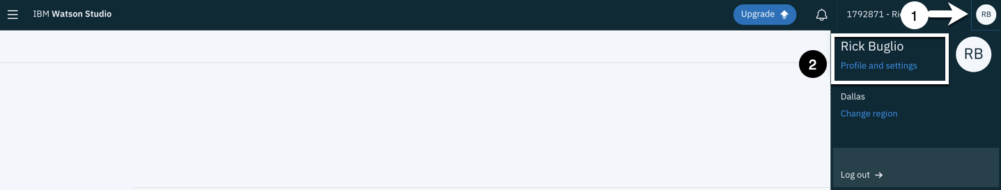

1. Select the **Account Menu** in the top right corner.

By default, it will be your initials. If you updated your profile with an image, it will be an image.

2. Select the **Profile and settings** menu item link.

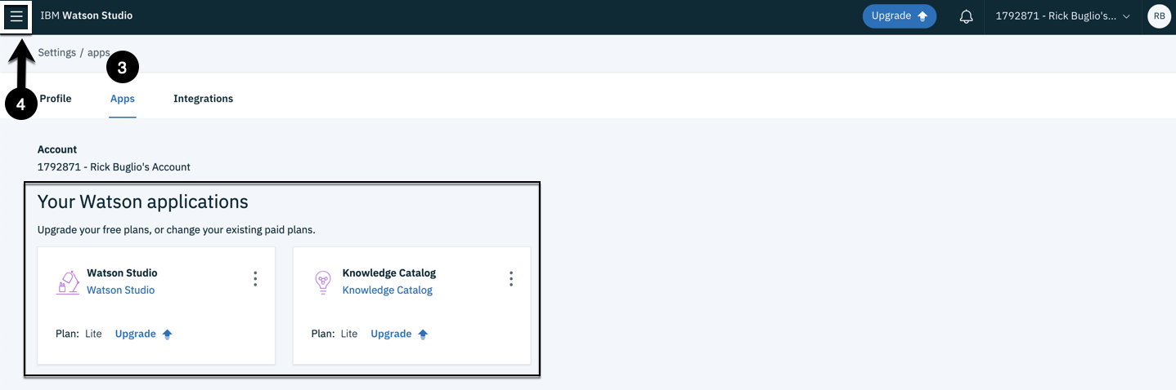

3. Click the **Apps** tab.

In the **Apps** section there should be a **Watson Studio** and **Knowledge Catalog** application created and listed.

4. Click on the **Navigation menu** that looks like a hamburger in the top left corner of the user interface.

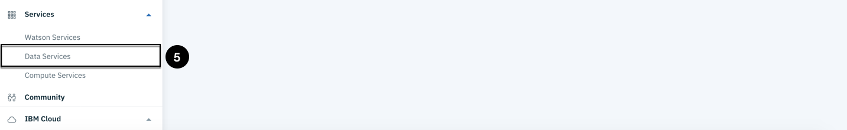

5. From the **Services** section, select the **Data Services** menu item.

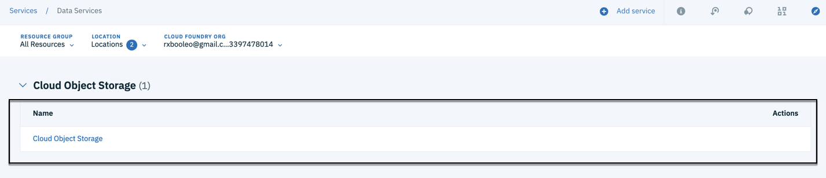

In the **Data Services** section, there should be a **Cloud Object Storage** service listed. The name of your service may be different from the one displayed in the screen shot above, but you should and must have one created.

If you are missing any of the **Apps** or the **Cloud Object Storage** data service, go to the **Prerequisites** section, at the beginning of this tutorial, and follow the steps to create them before you proceed.

### 3. Create a Governed Knowledge Catalog and Studio Project

In this task you create a governed **Knowledge Catalog**. Watson Knowledge Catalog is a secure, collaborative enterprise catalog to discover, catalog and govern information assets. It is underpinned by a central repository of metadata describing all the information managed by the catalog with full end-to-end capabilities around data lifecycle and governance.

If you already have a Knowledge Catalog created, and you are using the **Lite** or **Standard** edition of Knowledge Catalog, you will not be able to create another one. If so, use an existing catalog for this tutorial and proceed to the next task; 

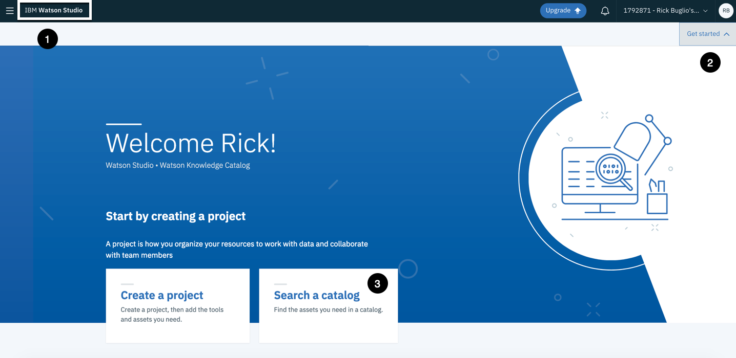

1. Click the **IBM Watson Studio** home button to go back to the home page.

2. Click the **Get Started** button in the top right corner of IBM Watson Studio.

3. Click the **Search a catalog** tile.

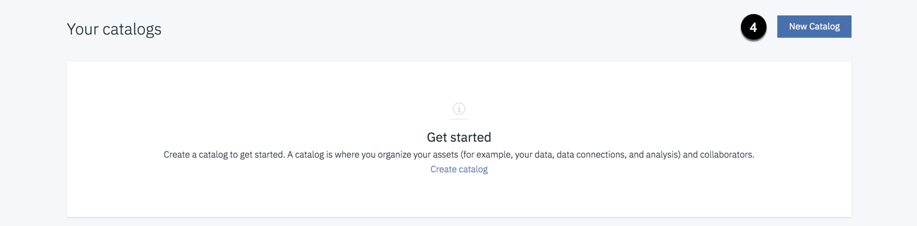

4. Click the **New Catalog** button in the top right corner.

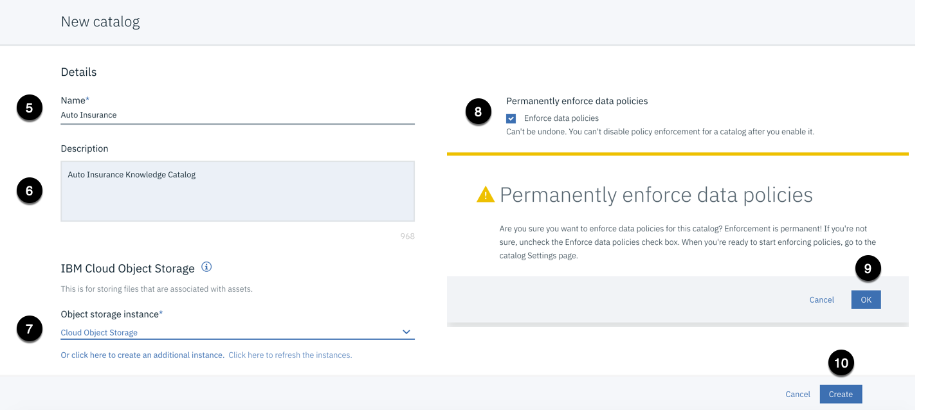

5. Enter a Name of **Auto Insurance**.

6. Enter a Description of **Auto Insurance Knowledge Catalog**.

7. Select an **Object storage instance** from the drop-down list.

Most likely, there will only be one listed and it will be pre-selected.

8. Select the **Enforce data polices** checkbox. [***Very Important***]

The **Permanently enforce data policies** warning dialog will be displayed, asking if you are sure you want to set this option and   
informing you that the setting is permanent.

9. Click the **OK** button.

By default, access to data assets in a catalog is only restricted by the privacy settings of the data assets. Privacy settings and policy rules can limit which members of the catalog can view and use the assets. You can implement data policies to restrict access to data based on the contents of the data. Data policies help you control data access and ensure that the right people can access the right data. Selecting the option to **Enforce data policies** enables the enforcement of data policy rules to allow or deny access to a data asset or mask, anonymize and redact data at the data asset field level.

Setting this option for a catalog is a good best practice. Once it is enabled, it cannot be undone, but it does not restrict or impede any functionality, it provides additional security measures to protect data assets.

10. Click the **Create** button.



You will see a **Creating Auto Insurance** notification during catalog creation.

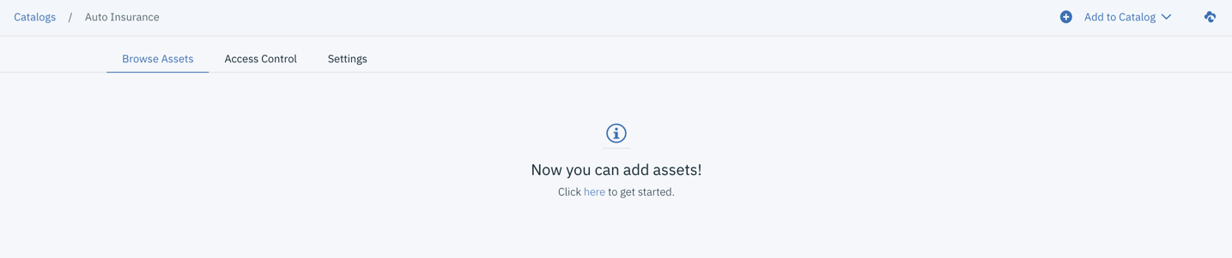

Once completed, you are brought into the newly created catalog. ‘**Auto Insurance**’  
  
4. Create Watson Studio Projects

In this task you will create two Watson Studio projects.

The first project, which will be named **Auto Insurance**, will be used by the auto insurance analytics team, to collaborate and build the analytic and AI assets; notebooks, models, data flows, dashboards etc. to analyze the auto insurance claims process. You will add auto insurance data assets from the **Auto Insurance** knowledge catalog to this project and do some shaping of the data using the **IBM Data Refinery** to prepare the data for analytical insights.

The 2nd project, which will be named **Auto Discovery**, will be used to demonstrate the auto discovery capabilities of Watson Knowledge Catalog. When you catalog a **Connection** in Knowledge Catalog, you can choose the option to automatically discover data assets. The discovered assets are added to a Watson Studio project as a temporary holding area for review. You will use a separate project for auto discovery, so it does not disrupt the data analytics project. Once data assets are discovered and added to a project, you can review them, determine which assets are relevant and then publish them to a Knowledge Catalog.

***Create the Auto Insurance Project***

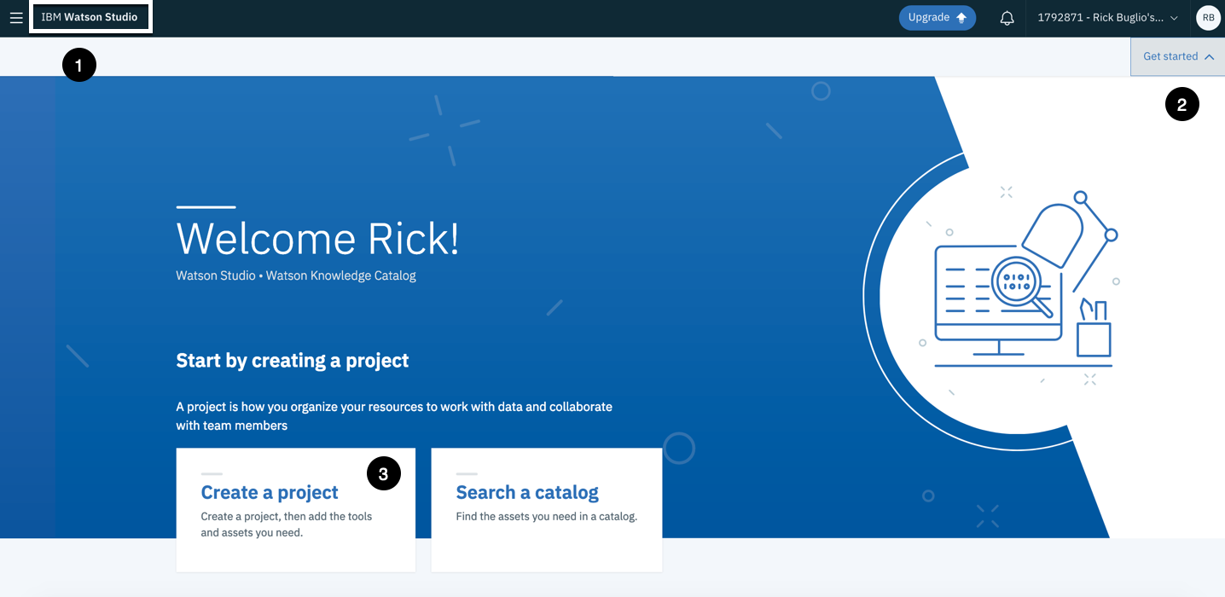

1. Click the **IBM Watson Studio** home button to go back to the home page.

2. Click the **Get Started** button in the top right corner of IBM Watson Studio.

3. Click the **Create a project** tile.

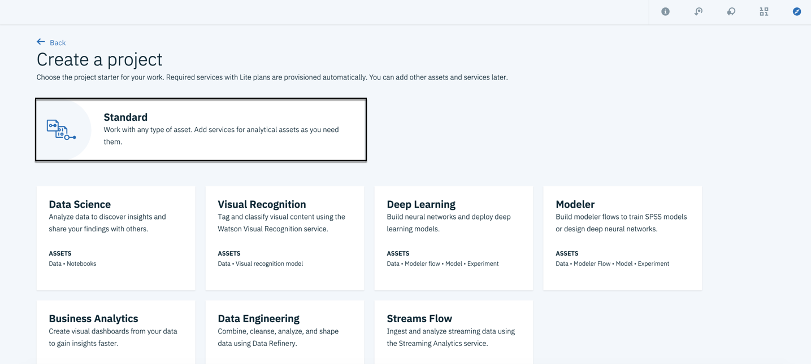

Hover over the **Standard** project tile with your mouse.

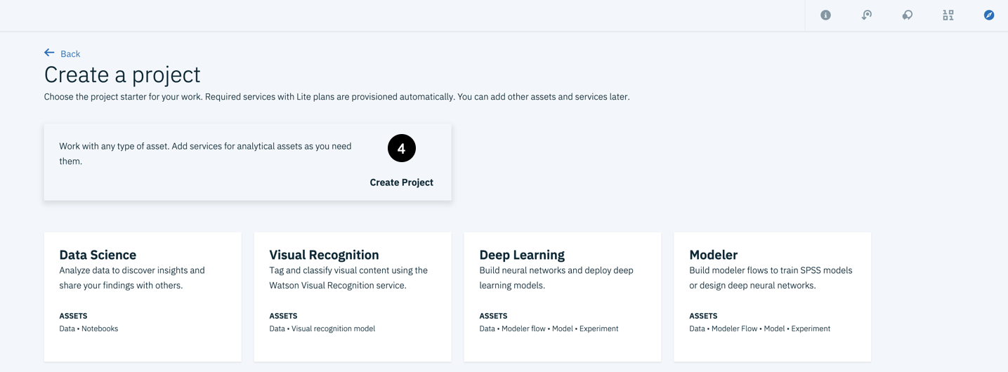

4. Click the **Create Project** button.

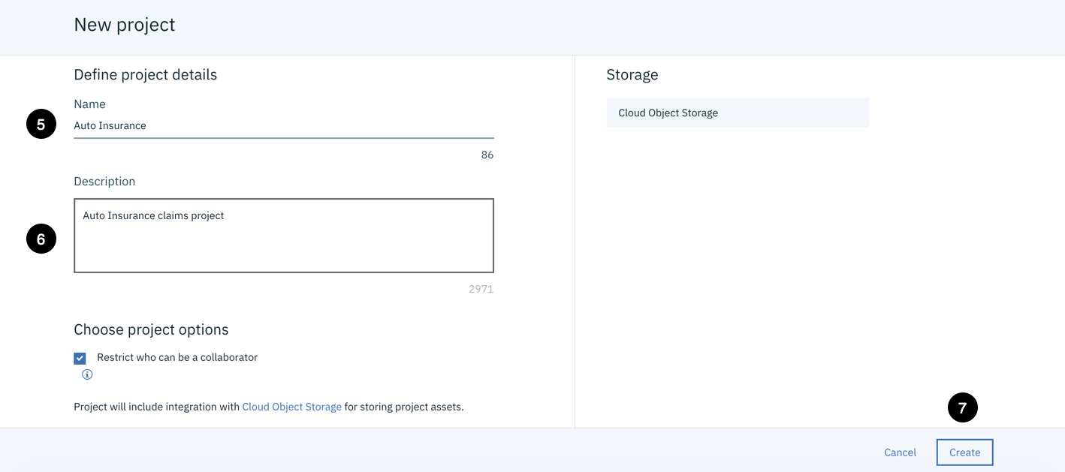

5. Enter a Name of **Auto Insurance**.

6. Enter a Description of Auto Insurance **claims project**.

7. Click the **Create** button.

The Create button will turn to **Creating…** so be patient and wait for the project to be created.

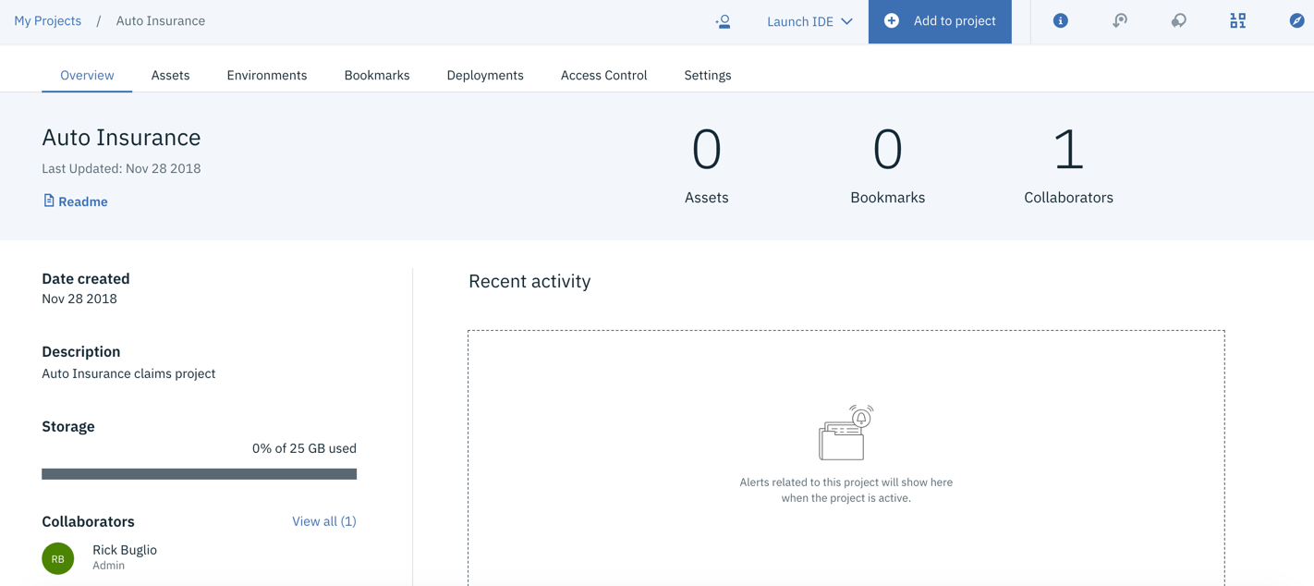

When the project creation is complete, you are brought into your newly created project and you will see the **Overview** section.

### 5. Discover and Catalog Data Assets

In this task, you will discover unstructured data assets from the local file system and structured data assets from a **Db2 Warehouse on Cloud** connection that you will create. This will introduce you to the three methods available to discover and catalog data assets; **Local files**, **Connected asset** and **Connection**. You will use these methods to catalog data assets into the newly created Knowledge Catalog and then tag them for users to easily find them, understand their content and make them available throughout IBM Watson Studio, for use during data preparation and within models, dashboards and notebooks.

Catalog Unstructured Data

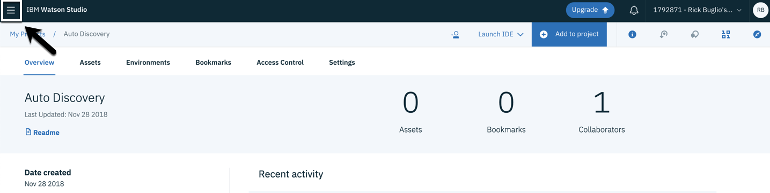

Click on the **Navigation menu** that looks like a hamburger in the top left corner of the user interface.

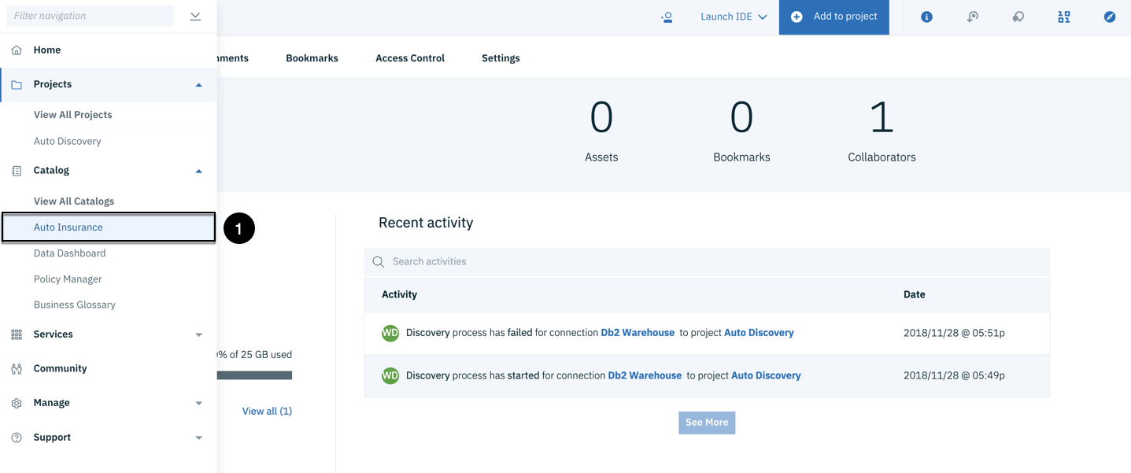

1. From the **Catalog** section, select the **Auto Insurance** catalog to go to the newly created catalog.

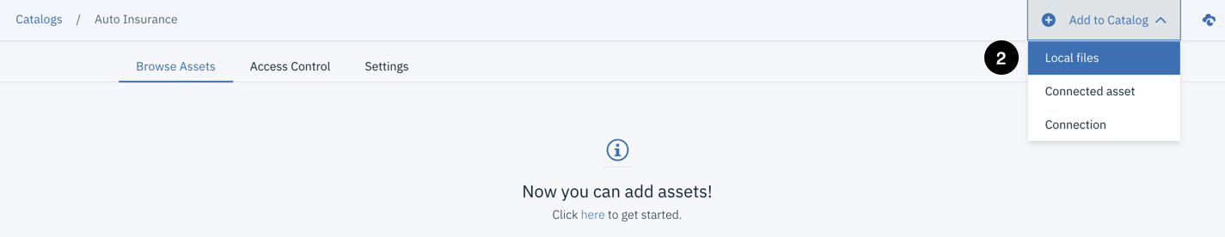

2. Click **Add to Catalog > Local files** from the catalog menu.

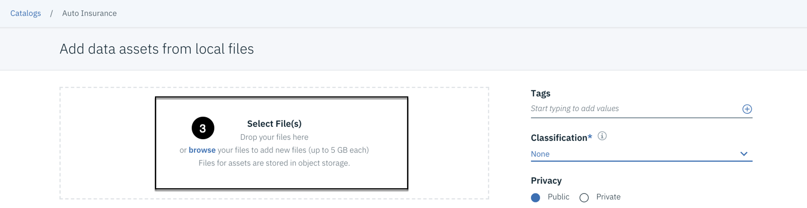

3. Click the **browse** link in the **Select File(s)** section to bring up the file selection dialog.

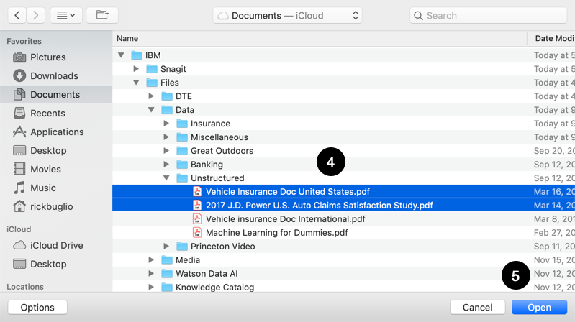

The MacOS **Finder** dialog is displayed. If you have a Windows system, it will look different, so depending on what system you are running, adjust to your system’s method of selecting files.

4. Locate the **“Vehicle Insurance Doc United States.pdf”** and the **“2017 J.D. Power U.S. Auto Claims Satisfaction Survey.pdf”** files on your file system that you were instructed to download. Select both using the **Ctrl or Command key** on your keyboard (Ctrl + Click for Windows and Command + Click for MacOS).

5. Click the **Open** button to begin cataloging the files.

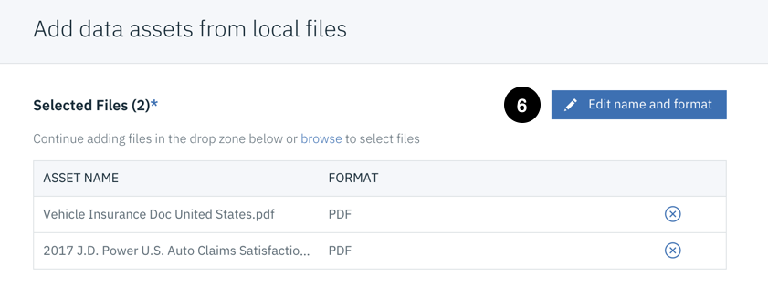

6. Click the **pencil icon** next to the **Edit name and format** link.

This allows you to rename the data assets and change their file format. A default file format is inferred for you based on the file extension. In this case, they are PDF files, so **PDF** was auto selected. You **will not** change the format, but you will change their names by removing the file extension.

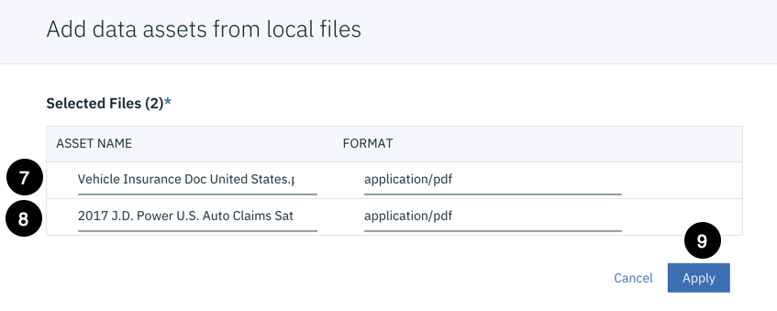

7. Click in the **ASSET NAME** area of the **“Vehicle Insurance Doc United States.pdf”** file. Go to the end of the file name and Remove the **.pdf** extension.

8. Click in the **ASSET NAME** area of the **“2017 J.D. Power U.S. Auto Claims Satisfaction Survey.pdf”** file. Go to the end of the file name and Remove the **.pdf** extension.

9. Click the **Apply** button to save the file name changes.

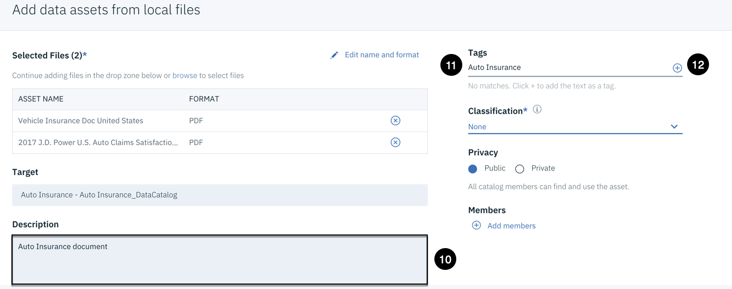

10. Enter a Description of **Auto Insurance document**.

11. Enter a Tag of **Auto Insurance** into the **Tags** area.

12. Click the **+** sign next to the tag to add it.

Every time you enter a tag, you need to select the **+** sign to add the tag. The tags will appear as added tags in the tag area below the tag name. Once a tag is added, it can be used and selected for other data assets. Knowledge Catalog displays all available tags once they are added to the catalog. You will see this in action when you add the next file to the catalog.

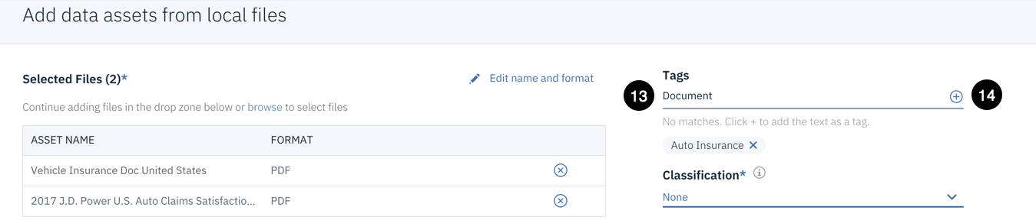

13. Enter a Tag of **Document** into the **Tags** area.

14. Click the **+** sign next to the tag to add it.

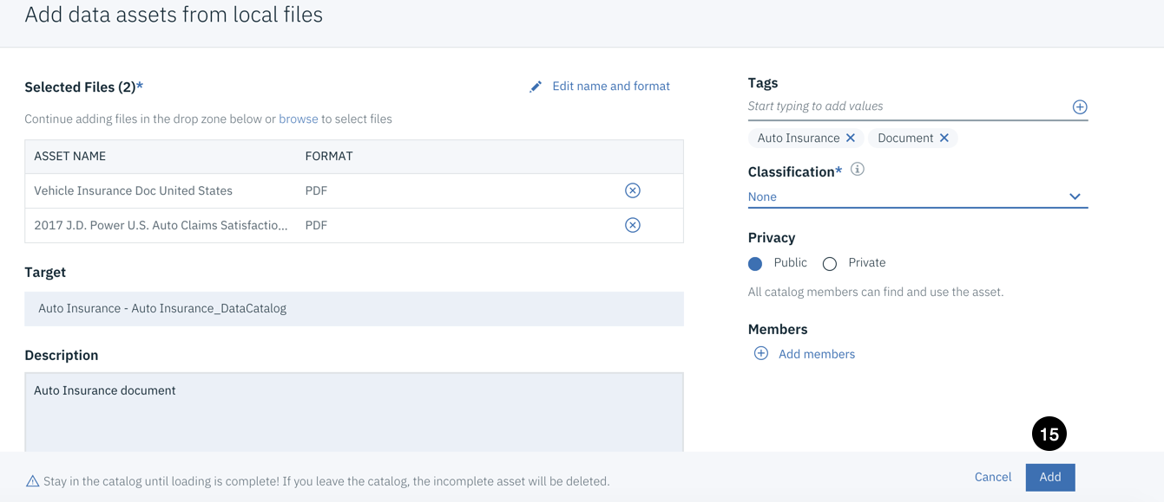

The screen shot shows the **Auto Insurance** and **Document** tags that you should have entered for this asset. Make sure you have added them before you proceed to the next step that catalogs them.

15. Click the **Add** button to catalog the unstructured data assets.

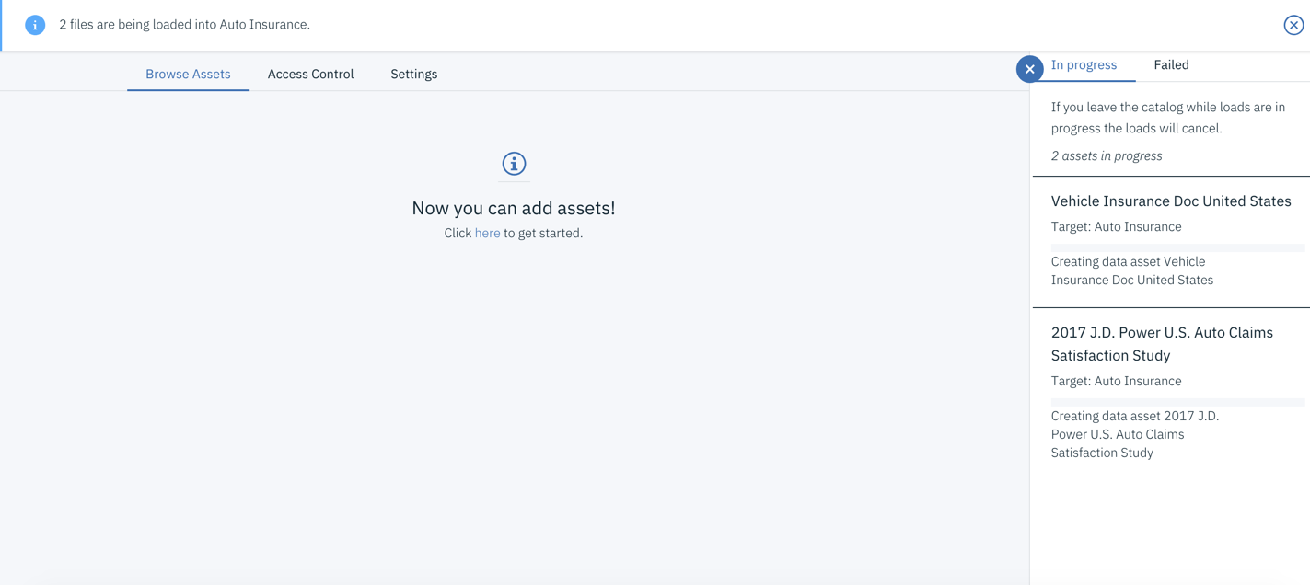

An **In Progress…** panel will appear on the right while the data assets are being added to the catalog.

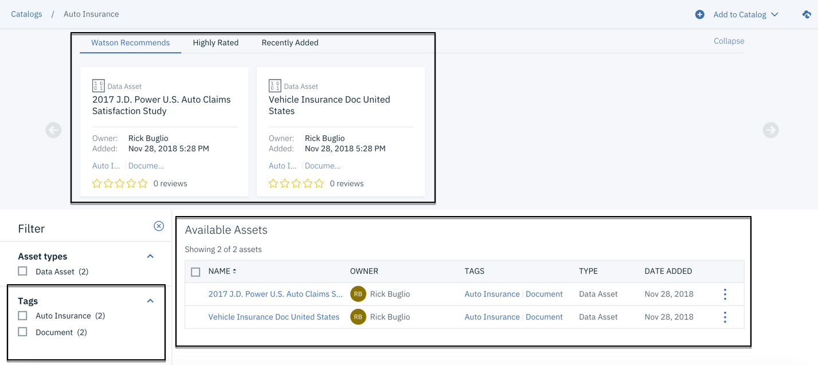

Upon completion, the data assets will automatically be added to the **Watson Recommends** section of the catalog asset browser. Scroll down and you will see the two newly added documents in your catalog with the tags you specified. Notice that the **Auto Insurance** and **Document** tags have been added to the **Tags** filter area.

Auto Discover Data Assets

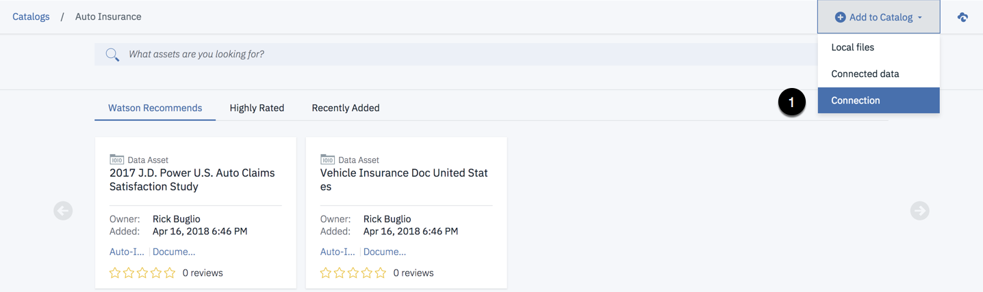

1. Click **Add to Catalog > Connection** from the catalog menu.

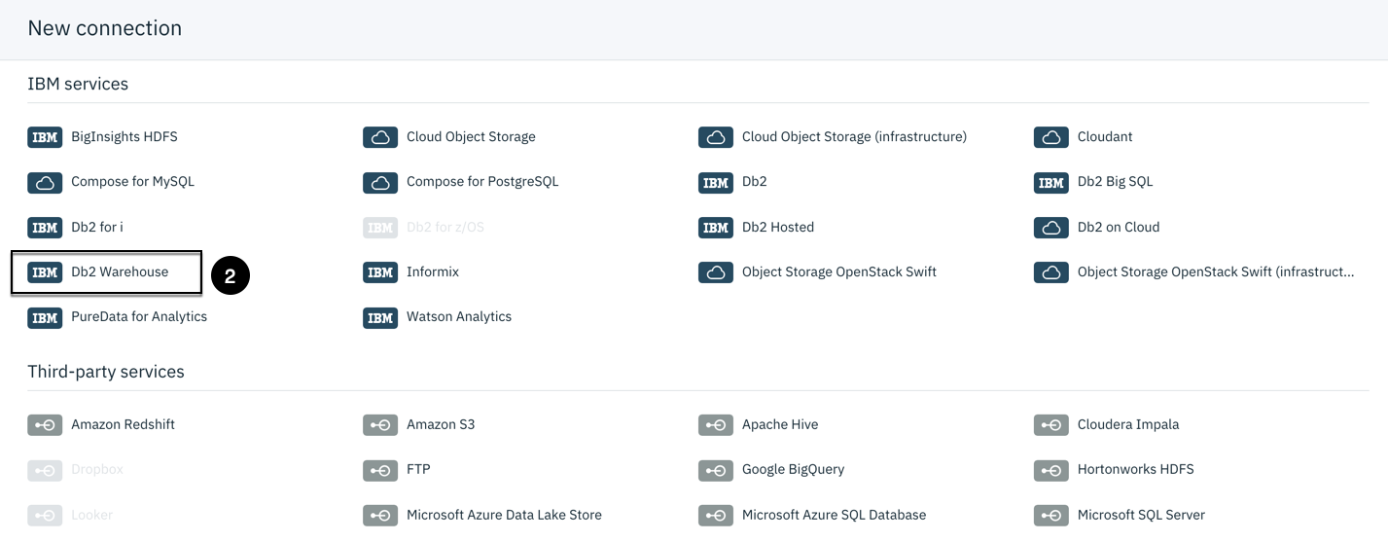

2. Click on the **Db2 Warehouse** connector.

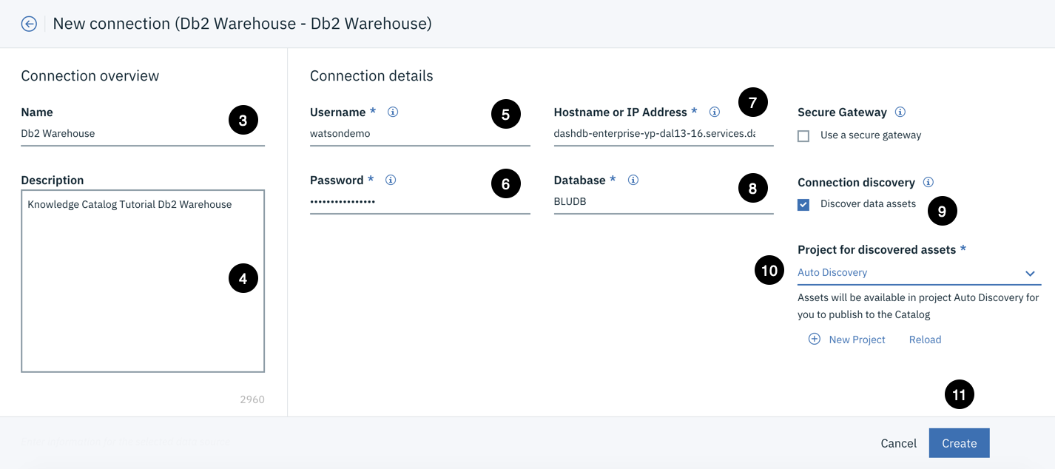

3. Enter a Name of **Db2 Warehouse**.

4. Enter a Description of **Knowledge Catalog Tutorial Db2 Warehouse**.

5. Enter a Username of ‘**watsondemo’**

6. Copy and Paste ‘**Wats0nDataandAI!’** into the Password field.

7. Copy and Paste ‘**dashdb-enterprise-yp-dal13-16.services.dal.bluemix.net’** into the Hostname or IP Address field.

8. Enter a Database of ‘**BLUDB’**

9. Click the **Discover data assets** check box under Connection discovery.

10. Select the **Auto Discovery** project from the "Project for discovered assets" selection list.

11. Click the **Create** button.

You will receive a message that Knowledge Catalog is waiting for a response from the connection service (this is the auto discovery service) and a completion and redirection message. You will be brought back to the catalog asset browser and should see your newly added connection in the Data assets list.

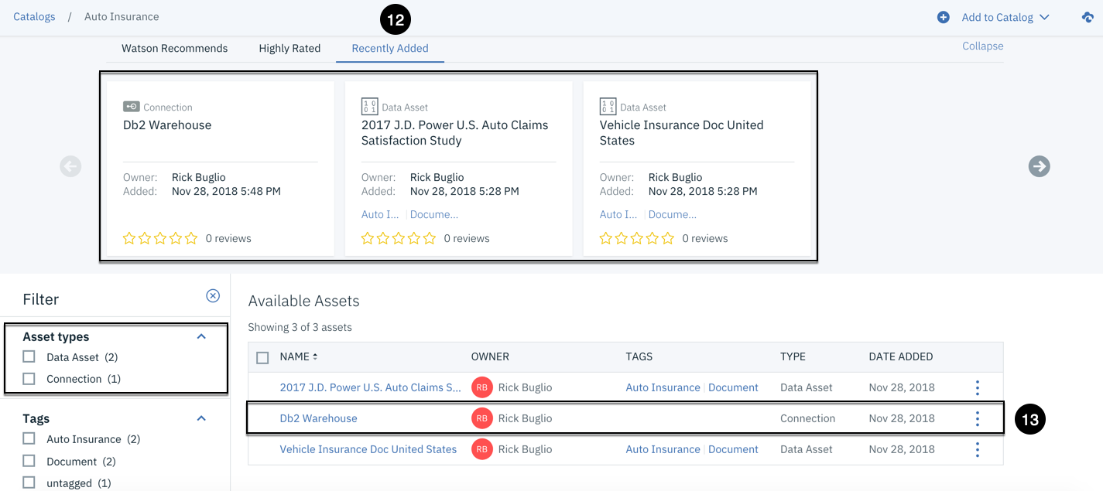

12. Click the **Recently Added** section of the asset browser.

Notice that all the data assets you added appear in this section. As assets are cataloged, they are added to the **Recently Added** section of the catalog asset browser. Also notice that the **Filter** section has a new Asset type of **Connection** with a count of (1).

13. Click on the **Db2 Warehouse** connection from the **Available Assets** list.

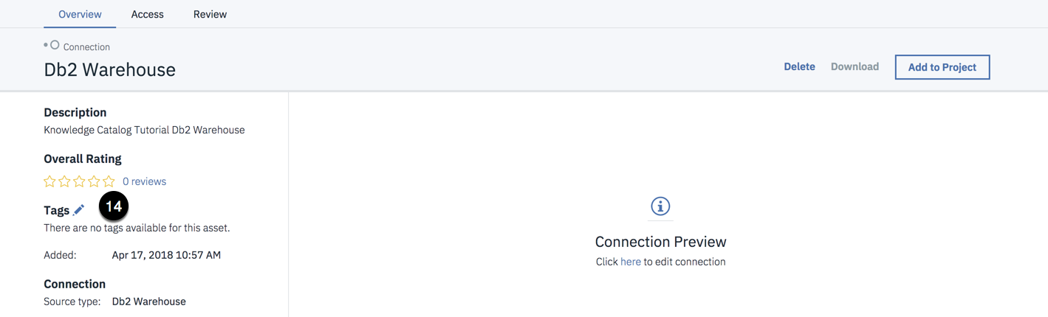

14. Hover next to the **Tags** section and Click the **pencil icon** to add tags to the connection.

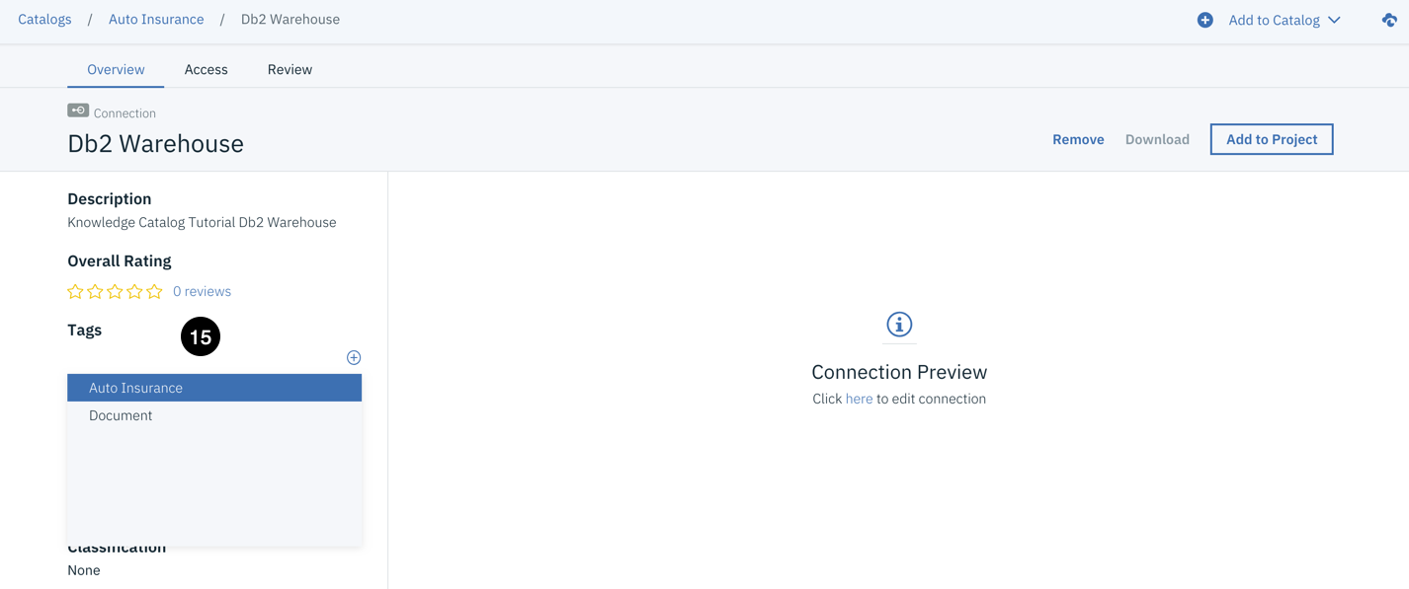

15. Click in the **Tags** section and select the **Auto Insurance** tag from the list of tags.

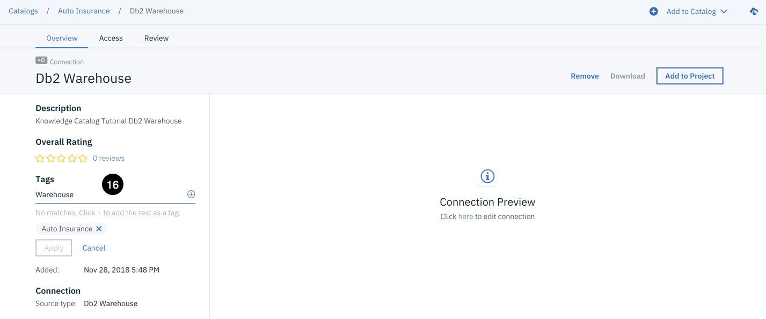

16. Click in the **Tags** section, Enter the word **Warehouse** as a tag and Click the **+**sign next to the tag to add it.

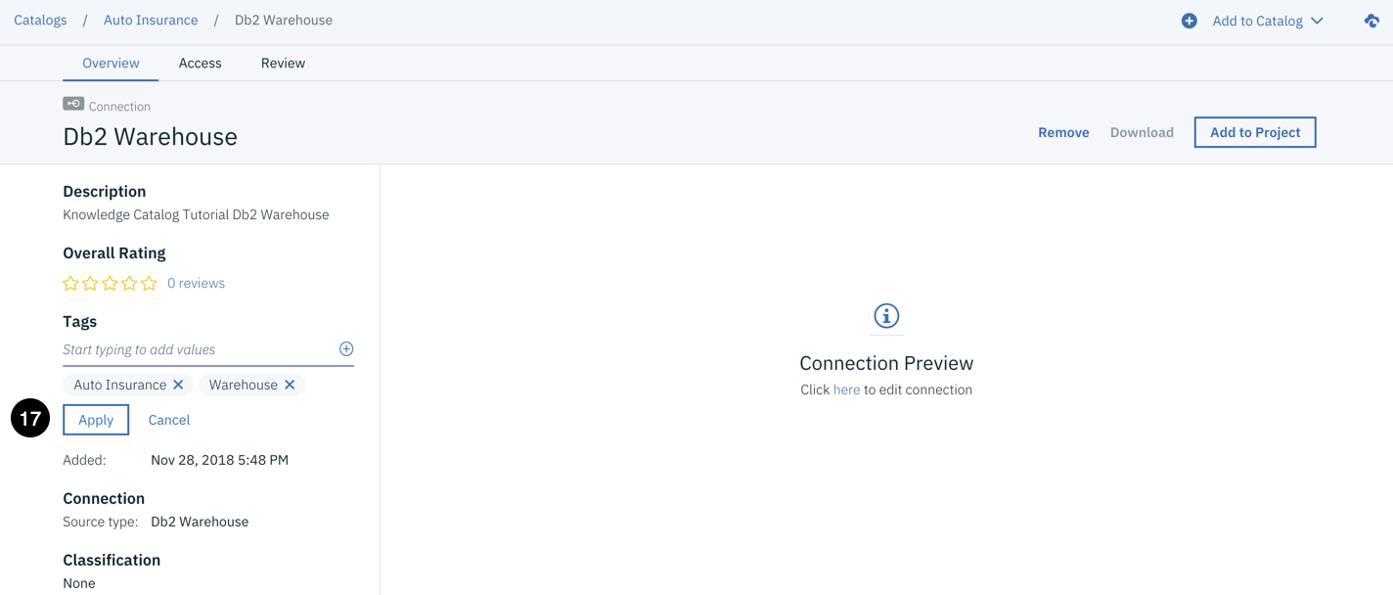

17. Click on the **Navigation menu** that looks like a hamburger in the top left corner of the user interface.

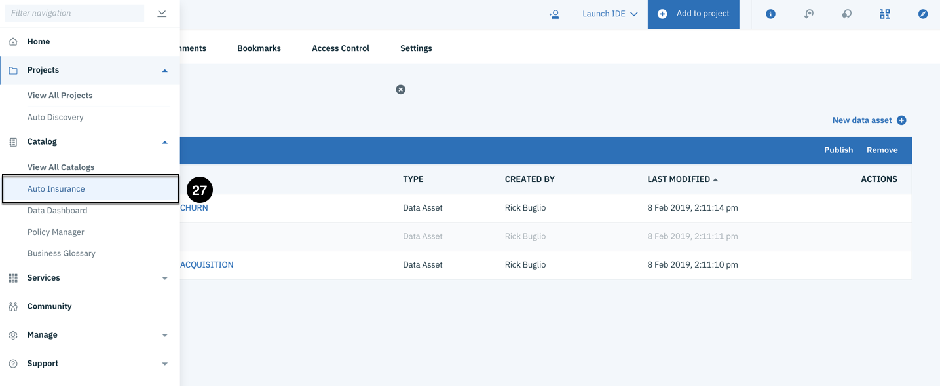

27. From the **Catalog** section, select the **Auto Insurance** catalog to go back to the catalog.

Catalog Structured Data

You have cataloged unstructured data files from the local file system and auto discovered data assets from a Db2 Warehouse connection. You will now catalog three tables from the Db2 Warehouse connection; Claims, Customers and Policies using the **Connected asset** catalog method. These tables are needed for the auto insurance claims analysis processing.

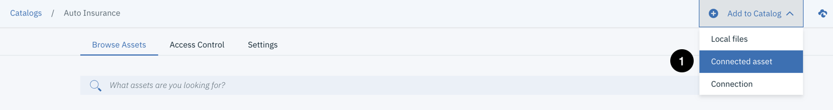

1. Click **Add to Catalog > Connected asset** from the Catalog menu.

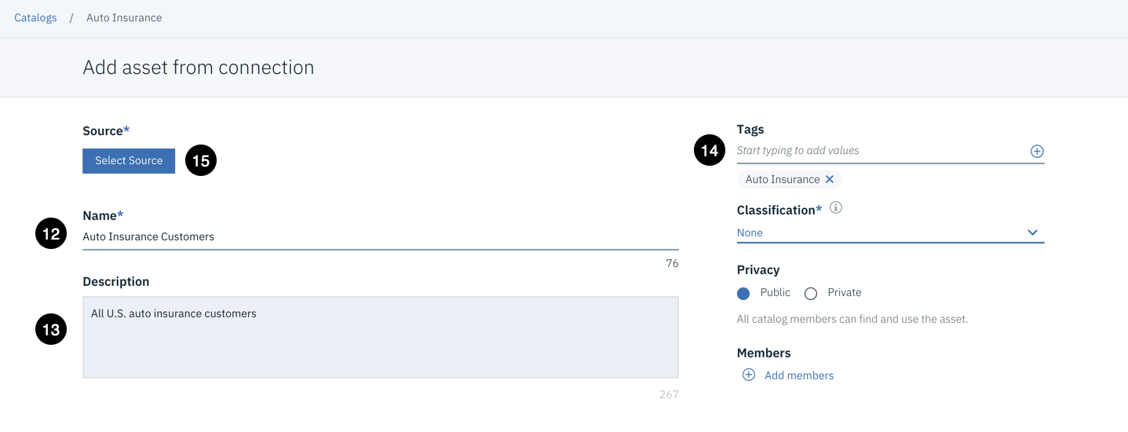

2. Enter a Name of **Auto Insurance Customers**.

3. Enter a Description of **All U.S. auto insurance customers**.

4. Click in the **Tags** area and select the **Auto Insurance** tag from the drop-down list.

5. Click the **Select Source** button to choose a Connection to add connected assets from.

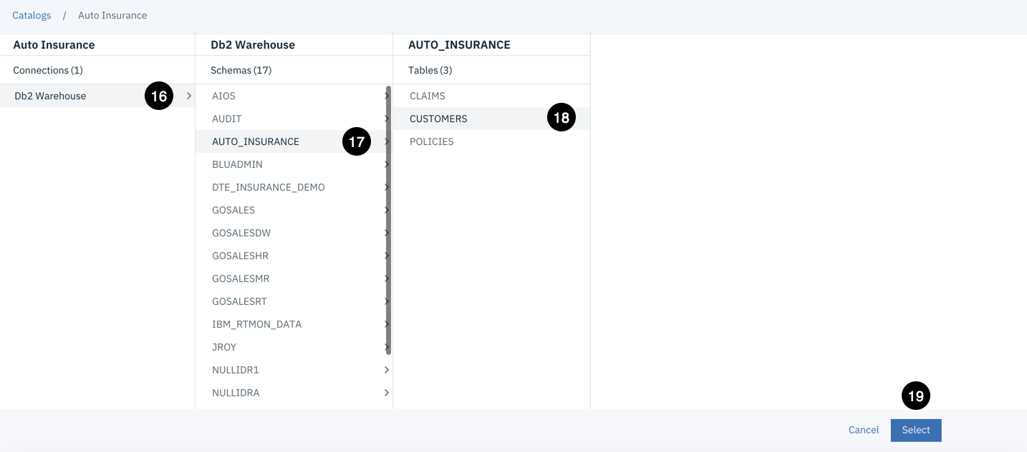

6. Click on the **Db2 Warehouse** connection from the list of connections.

7. Click on the **AUTO_INSURANCE** schema from the list of schemas.

8. Click on the **CUSTOMERS** table from the list of tables.

9. Click the **Select** button.

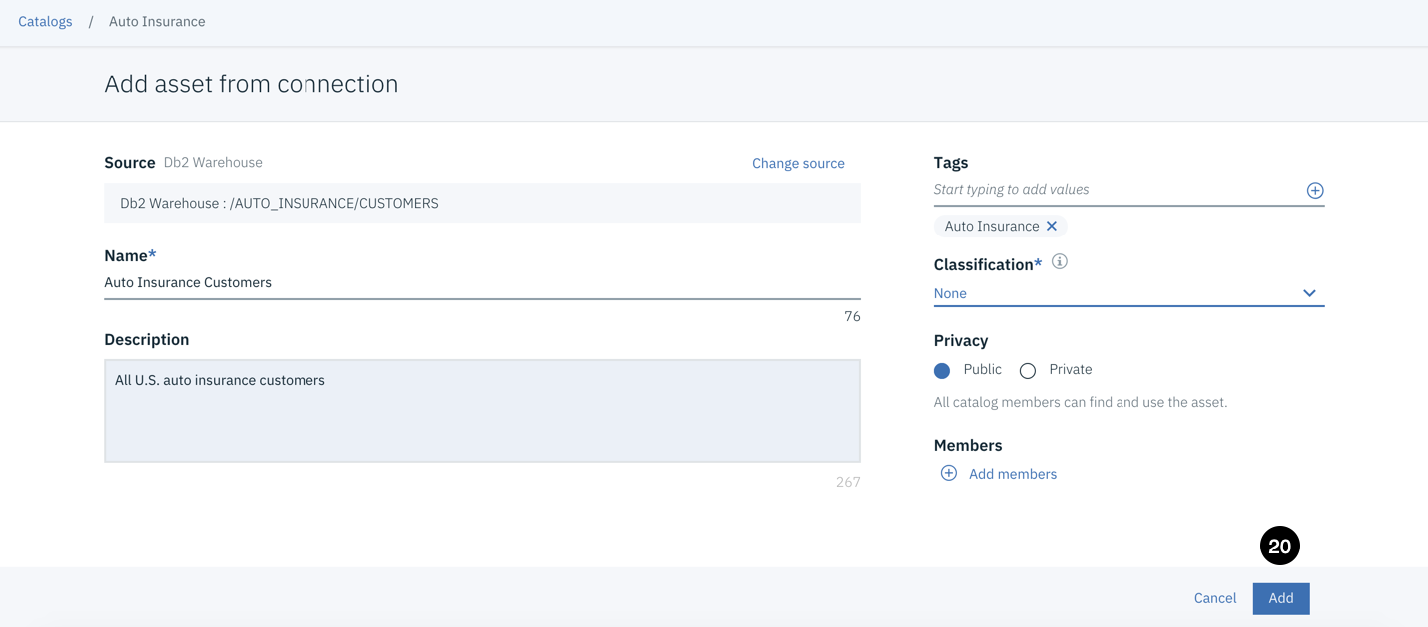

10. Click the **Add** button.

You should see the cataloged table as a data asset with the tag you supplied.

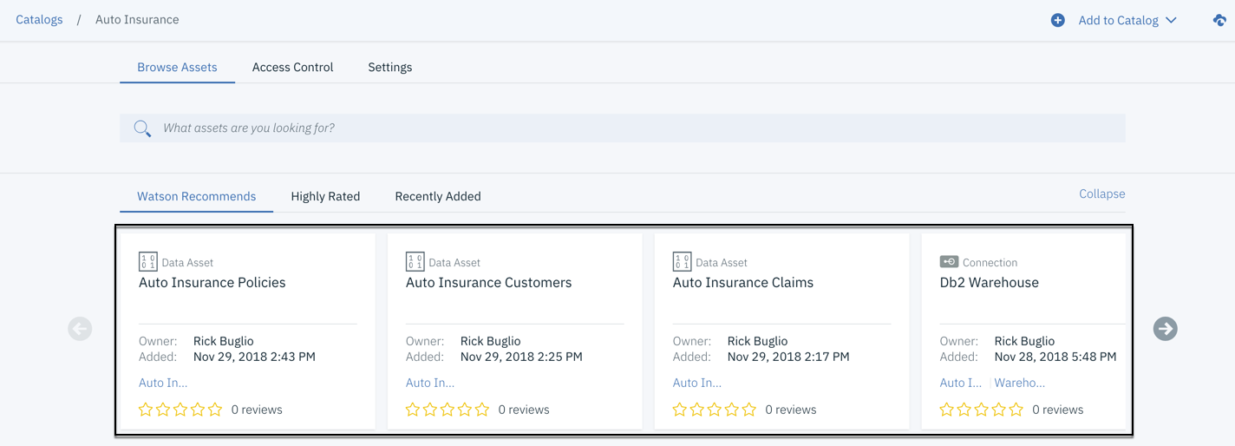

You should see the cataloged tables and data sets in ‘browse assets‘ with tags are reviews.  
  
Note: The same steps can be followed to pull-in the ‘CLAIMS’ and ‘POLICIES’ tables.

11. Click on the **CUSTOMERS** data asset and click on the **Profile** section of the data asset.  
Let us see the ***auto-profiling*** that is done by Watson, which gives us a high-level view of the data we have.

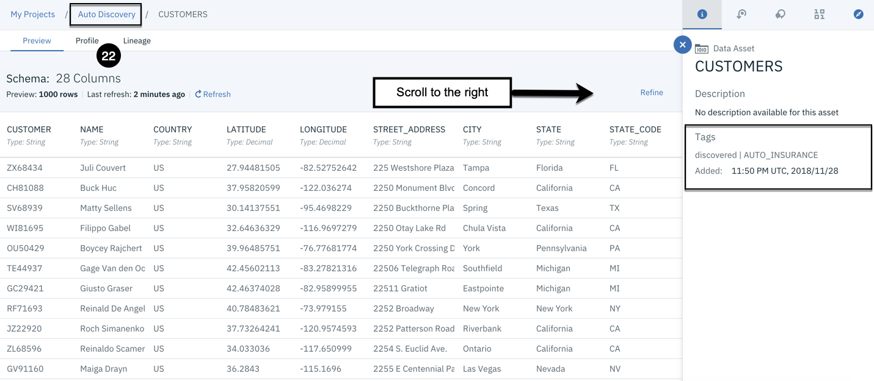Now, after seeing the data, we can click on ‘**Review’** section to rate and review the data asset with your desired comments.  
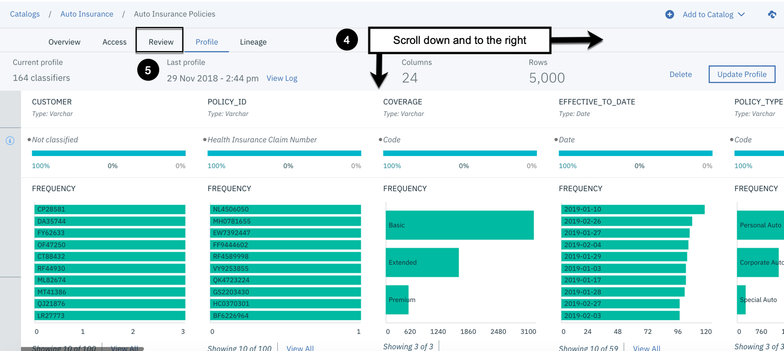

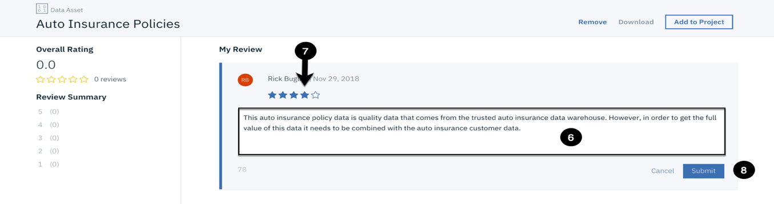

**6. Apply Governance on Data to Restrict access and viewing**Let us hide some sensitive information like Gender, Credit Cards etc.  
Click the **Navigation menu** in the top left corner of the user interface.

1. From the **Catalog** section, select **Business Glossary**.
2. Click the **Add Terms** menu.
3. Click **Create New**. Enter Name**,**Business Definition , Description, tag of Sensitive and

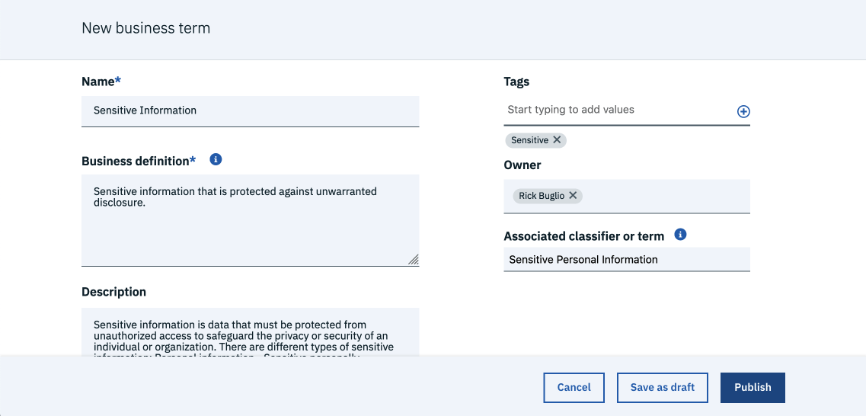

Click on **Publish.** Once published, your business term will appear like below.  
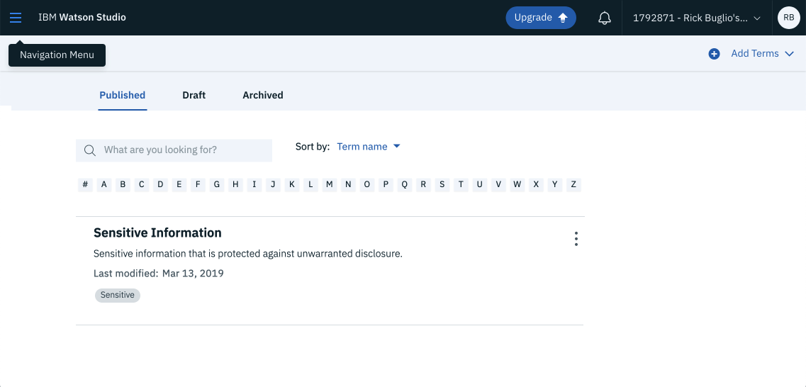**Creating a Data Governance Rule – to hide ‘Gender’ and ‘Credit Card’ Information**In this task, you use the *Policy Manager* to create a data governance **Rule** to enforce the protection of sensitive government identities, such as U.S. Social Security, Canadian Social Insurance and Passport numbers, and financial account information, such as credit card & Gender information.

1. Click the **Navigation menu** in the top left corner of the user interface.
2. From the **Catalog** section, select **Policy Manager**.
3. Click the **Add** menu -> **Rule**.
4. Enter the rule Name and Business definition,  
   In **Condition 1** select Business Term option  
   From the **Action** section, click the Action button. Select anonymize data.

Click the **Where** condition button and select in columns containing.  
In Action -> select anonymize data -> Financial Accounts & Personal Information

Select any masking option like Substitute and click on Create/Update.  


**Publishing a Data Governance Policy consisting a Rule.**In this task, you use the Policy Manager to create a data policy **Category** and publish a data governance **Policy**. You assign the policy to the data policy category and add the data governance rule you just created to the published policy. A rule is activated when you include it in a published data protection policy. Once active, the rule is enforced by the active policy management engine using the data protection methods defined by the rule.

1. Click the **Add** menu.
2. Click **Category**.

The category Name and Description have been entered for you below.  
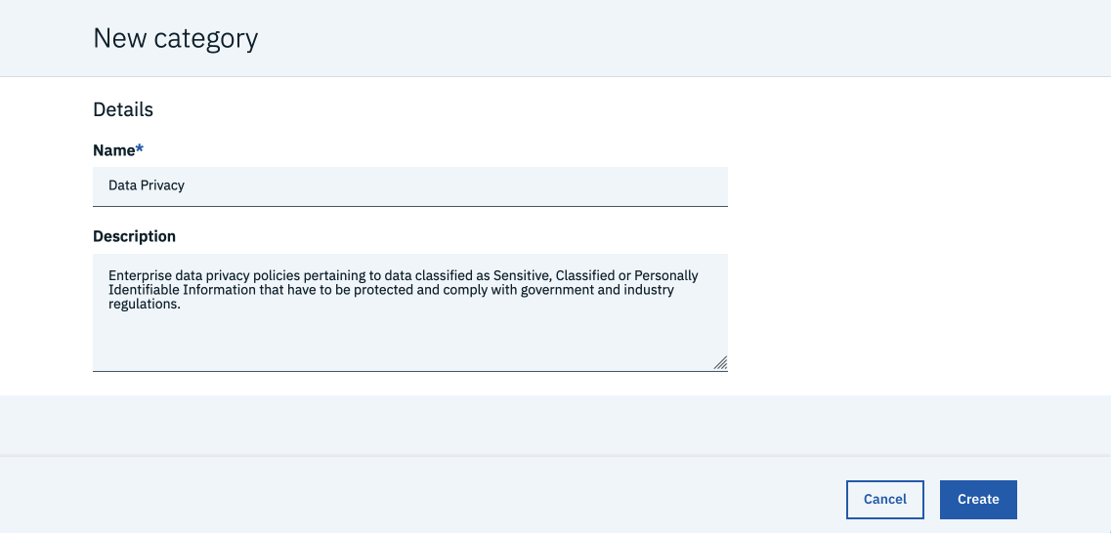

1. Click **Create**.

**Publish a data governance policy:**

Click the **Add** menu -> Click **Policy**.  
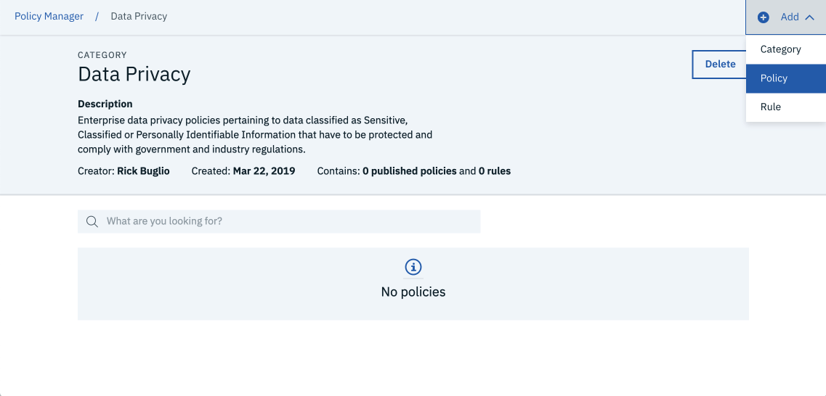

The policy Name and Description have been entered for you. The policy Type has been pre-selected. The policy Category of **Data Privacy** was pre-selected because you were in the category when you chose to create the policy.  
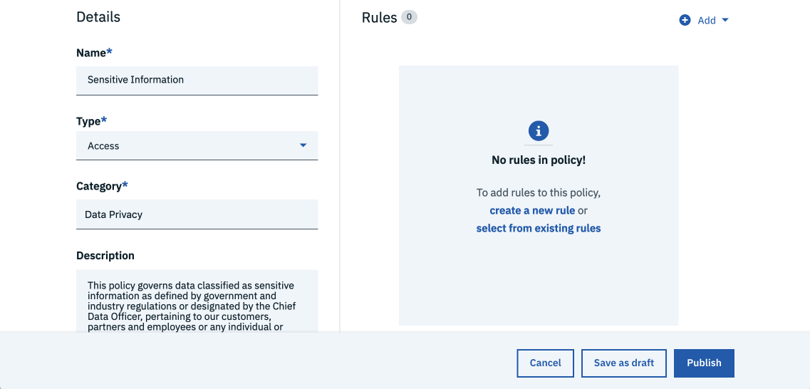

1. Click the **Add** button to add a rule.
2. Select **Existing rules**.
3. Select the **Sensitive Information** rule created in the previous task.



1. Click **Add**.
2. Click **Publish**.  
   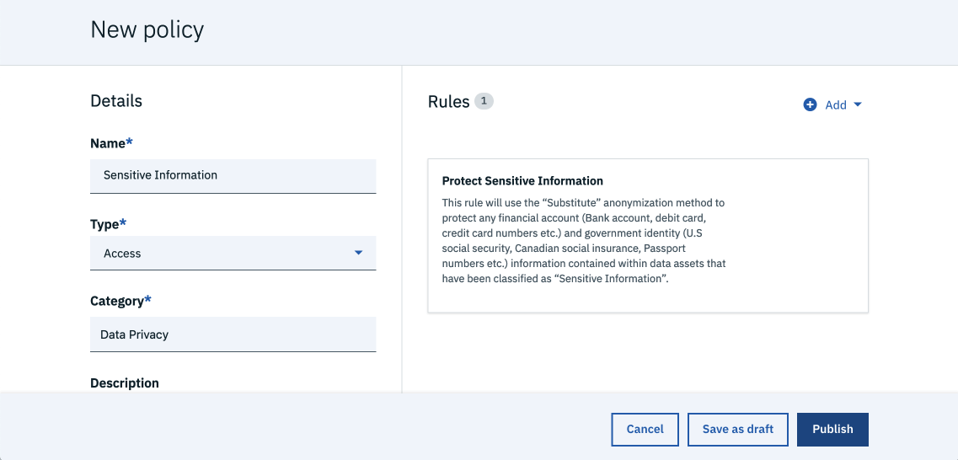
3. Click **Publish** in the confirmation dialog.  
   
4. Click on the **Sensitive Information** policy to expand it.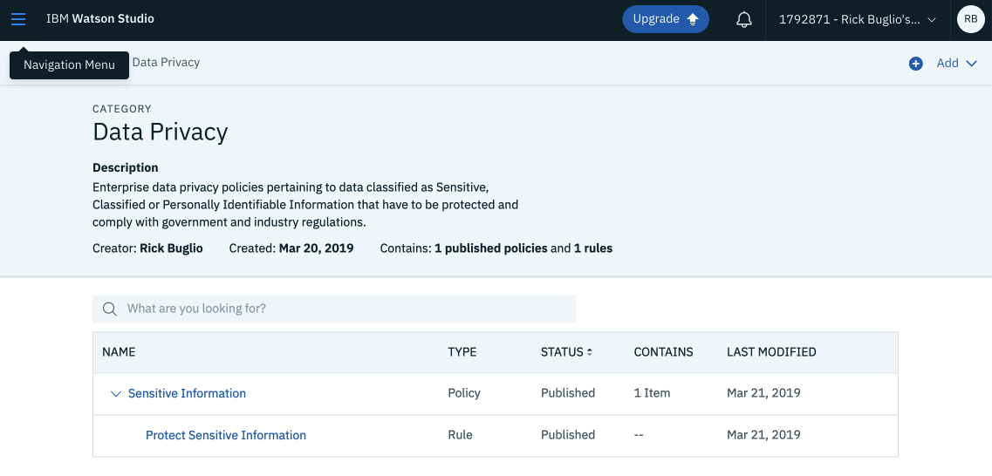

1. **Applying Policy to Data Asset ‘CUSTOMERS’**
2. Click on the **Navigation menu** in the top left corner of the user interface.
3. From the **Catalog** section, select the **Auto Insurance** catalog.
4. Click the **Auto Insurance Customers** data asset.
5. Click the **Scroll down** button to view more metadata attributes. Select **Business Terms** and enter the ‘Sensitive Information’ term that you have created and let the rules be applied on it and select the **Apply** button.
6. Go to ‘**Access’** and add another team member’s email ID having IBM Cloud account.
7. Once added, change the **Asset Owner** name to your team member and click **Apply**.  
   
8. Go to **Overview** & you will see the two columns **Gender** and **Credit Card Number** being anonymized as per your rule.  
   
9. Click on **Add to Project** to add this governed data asset to a Target Project for Analytics named **Auto Discovery** and click on **Add**
10. [Optional] To learn more –
11. Click on the **Navigation menu** in the top left corner of the user interface.
12. From the **Catalog** section, select the **Data Dashboard** option.
13. View the **Sensitive Information** enforcement to see which data assets it is enforcing currently.
14. **Scroll down** button to view the **Policy enforcements over time** graph, **Top ten most enforced policies**, **Operational policies** and **Automatic Enforcements.**

